V. UVA IN THE 1900s & 2000
TABLE OF CONTENTS
1. UVa in 20th Century Wars | …230
- World War I

- 1921 Centennial Celebration

- Leading Up to the Second World War

- World War II

- McCarthyism and the Cold War

- Kennedys Discuss the Cold War at UVa

- The Vietnam War Protests of May 1970

2. History of African-Americans at UVa | …240

- Building the Academical Village

- Early Years at the University

- Post-Fire Reconstruction and the Venable Lane Community

- First Applicants and Students

- Activism in the 60s & 70s

- Current Issues and Progress

- “Desegregated… but not Integrated”

- Civil Rights Protests at UVa

3. History of Women at UVa | …255

- Early History

- Turn of the Century

- Change in the 1920s

- A Growing Presence

- Breaking with Tradition

- After Coeducation

- Testimonials

4. Assorted Contemporary Stories | …264

- Georgia O’Keefe and William Faulkner

- Dr. Pepper, and Beta and Seal

- E-School Innovations
- Carr’s Hill and President Chronology


UVa and 20th Century Wars

World War I
Was the University open during this time? How did students and faculty participate in the war effort?

With the entry of the United States into World War I, all alumni and other University activities were curtailed or drastically altered.

- Enrollment at the University fell from 1,064 (for the 1916-17 session) to 761 and then to 536, despite the exhortation from the Wilson administration that all college students stay in college until called.

- A Reserve Officers’ Training Corps (ROTC) was organized as soon as we entered the war, and physically fit students eighteen years of age were automatically enrolled.
- The curriculum was modified to include courses needed in wartime: a truck driver’s school was organized and constructed at the University on directions from the War Department and at the University’s expense.

How did UVa’s alumni office help the men fighting in France?
The alumni secretary opened a bureau in Paris for UVa men in the service. He even translated “The Good Old Song” into French. Alumni News noted “the alumni office has done its share of war work by raising two U.Va Ambulance Sections for the U.S. Army, and by cooperating in the organization of the U.Va Base Hospital,” which reached Paris in July 1918.

What event led the Board of Visitors to take a stance on the limits of freedom of speech?

After journalism professor Leon R. Whipple made an aggressively antiwar speech at Sweet Briar College in November 1917, he was widely denounced in the press and President Alderman recommended that he be dismissed from the University. While most professors disagreed with Whipple’s views, at least one publically defended Whipple’s First Amendment right to hold and express unpopular views. Regardless, the Board of Visitors found his utterances to be “a gross abuse of freedom of speech” and agreed unanimously with Alderman; the professor’s appointment was terminated.

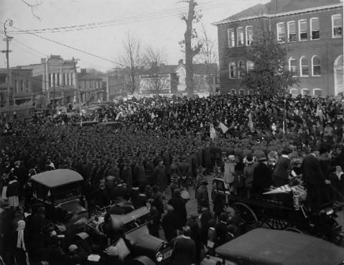
What happened after the armistice?

With the arrival of the armistice, November 11, 1918, there was fervent rejoicing on both sides of the Atlantic. Robert P. Hamilton, Jr., a university student serving abroad and eventual Rhodes Scholar, was in Paris on that memorable day. He wrote his mother at once, expressing his deep emotional involvement: “Paris on November the eleventh, 1918, was the stage of such scenes as occur once in the history of the world. They

had no rehearsal and they can have no repetition. For my part I had rather die tomorrow with the precious memories of yesterday thrilling my soul than to live to seventy with that golden date erased from my mind.”

What else was significant about the year 1919?

The year 1919 also marked the centennial of the University’s chartering. Hundreds of University servicemen were still overseas that spring, and students arranged a Founder’s Day observance for April 12 and 13 in Paris.

How is WWI commemorated today at the University?

Some 2,700 University of Virginia alumni and students had served in the armed forces, and 80 had given their lives. A plaque in their honor can be found outside the Rotunda. Additionally, “The Aviator” statue outside of Clemons is donated in honor of student and fallen WWI pilot James McConnell. It was built by Gutzon Borglum, the sculptor of Mount Rushmore.

UVa’s 1921 Centennial Celebration

From Alumni News, 1921

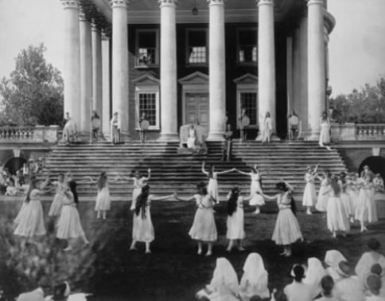
The celebration, which should have occurred in 1919, was deferred until June of 1921 due to the war and the “disorganized state of affairs” in its aftermath. One man recounted, “the idea of an adequate description or account of the Centennial Celebration is appalling. The idea too closely resembles the futile task of painting the lily or perfuming the rose. Seeing everything that went on in a three-ring circus would have been easy in comparison with an attempt to take in all the events and features of the Centennial. If ever there were four fast, furious and frantic days, them were they.”
Scene from University Centennial Pageant, 1921

Leading Up to the Second World War

What sparked the Anti-War Movement across colleges in the United States in the 1930s?

The hardship of the Depression led to increased political activism across the nation’s campuses. Students realized should war arise, they’d be the ones called to fight. Fearful of another global disaster like the First World War (which still permeated students’ memories), groups formed to discuss economic problems and methods of curtailing warfare.

Why were protests and debates at UVa more subdued?

Virginia men were typically both too conservative to embrace radical ideas and too tied to their gentlemanly reserve to speak out. Sure, debates still flurried over oncoming war at UVa, but unlike other schools that had to fight to voice their opinions at all, UVa’s tradition of student independence permitted free speech. The student paper College Topics began publishing anti-war material in 1934.

What were the students’ political leanings?

In a poll of 500 UVa students, 250 said they would fight if the United States were invaded, 179 would fight any American war, and 73 would not fight under any circumstance. While the majority of students clearly were not sympathetic to the anti-war or pro-communism groups around Grounds, there still existed that sizable minority with pacifistic leanings. The two sides argued over President Newcomb’s proposed re-implementation of a required student militia (R.O.T.C.). Which was more Jeffersonian: fighting to protect free government, or the right to free individual thought and action? Pacifists staged an anti-war rally, but it ended up far from the radical strike some students had hoped for. Most students remained isolationists, wishing for the U.S. to stay out of Europe’s conflicts.

Why did the anti-war debate at UVa temporarily subside?

The University became distracted by the controversy ensuing from the application of Alice Jackson, the first African-American to apply for admission to the University. But as both fascism and the threat of war grew abroad, war would not be absent from students’ minds for long.

What was the climate like before Pearl Harbor?

In the four years preceding the Pearl Harbor attack, the University was saturated with speakers on the international situation, focusing on the most advisable course of action for the United States or Hitler’s invasion of Czechoslovakia. Speakers such as Dr. Heinrich Bruening, a former chancellor of Germany, attracted large audiences in Cabell Hall auditorium. Student opinions were active on the pages of College Topics.

However, the most significant event at UVa leading up to Pearl Harbor was the re-establishment of military organizations at the University. In the summer of 1940, President Newcomb eventually did re-establish R.O.T.C. programs at the University. The Navy required 100 students to recognize the program; students quickly filled the quota that fall. The University of Virginia was ready for World War II, in mind and institution, by the time of Pearl Harbor.

World War II

All of the various military and naval units located at the University during the war kept the institution alive and functioning when so many of the regularly enrolled students had left college to enlist. Much of the cost of instruction, as well as of food and housing, was paid for by the federal government. President Newcomb and the faculty remained firmly in control as teachers and researchers, and as referees over Army-Navy rivalries.

Were the students and faculty supportive of the war?

A few faculty members and students at the University were already involved on the side of the Allies, but the great majority was strongly determined to avoid entering the war. They had been sympathetic to Great Britain and France, while remaining resolutely opposed to “fighting Europe’s battles.” But the Japanese attack on Pearl Harbor caused an instant revolution in the climate of opinion on the campuses of America. “College students—long criticized for their peacetime isolationist leanings—have immediately united and are ready for the personal sacrifices the war will demand,” said College Topics.

How did students prepare to serve in the war?

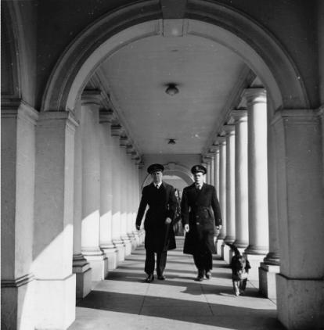
UVa had a Naval ROTC program, and was cooperating with the Navy in a long-range program of student training designed to turn out men who would be ready to take positions as junior officers on ships and planes. The Naval ROTC moved from Thornton Hall to Maury Hall, the newest building on the Grounds, where courses were offered in such subjects as naval training and navigation, seamanship, electricity, ordnance and gunnery, engineering, naval history, administration, regulations and leadership, communications, aviation, military and international law, and infantry drill. Programs of physical training were announced: a series of ‘V’ Tests” by which students could judge their physical fitness. Included were sit-ups, pull-ups, floor dips, the quarter-mile run, the one hundred yard swim, wall scaling, and so on.
Students in Officer Training School during WWII

All students between 17 and 26 years of age were called to meet in Cabell Hall in April 1942, at which time they were told by President Newcomb how they could complete their officer training in the Army, Navy, or Marine Corps while finishing their college courses. Every able-bodied student in the University would be in some branch of the armed services within six months, it was stated.

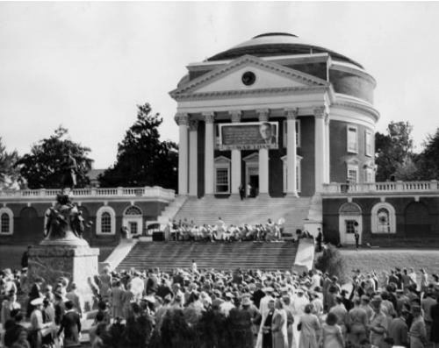
How did students and faculty contribute to the war effort?

The bottom fell out of UVa applicant base and many students chose to postpone their studies in order to serve in the War. The administration did what it could to forestall losing its students to the War (though it never went so far as to allow women or blacks admission previously denied to them). Even before the attack on Pearl Harbor, University professors undertook a series of state-wide lectures and discussions on “democracy and its obligations.” Universities generally viewed their duty at the early stage in the War as being protectors of democratic ideals. Such an agenda easily could be linked to the memory of Thomas Jefferson
War Bond Rally, 1943

“This has been a year of war. The University has changed in many ways: we have air raid squads on the Lawn, and many of our finest students are gone to fight for our country. The integral part of the University, however, hasn't changed - can never change - it is always embodied in the spirit of Jefferson, of Honor, Democracy and Liberty.”

More than 300 Virginia men would give their lives in the conflict, and maximum participation by all University students and personnel in the war bond drives was urged by President Newcomb, who was the first to buy a bond. Arrangements for accelerated study were in effect for the summer of 1942, to enable students to complete their degrees. It was announced in May that students in all departments would be completing degree programs in June, Septembers, Decembers, and March. The University, in collaboration with the city of Charlottesville and the county of Albemarle, was preparing for possible service as a hospital evacuation center for Washington, Baltimore, or Norfolk.

Which important speech occurred on Grounds?

On June 10, 1940, President Roosevelt addressed graduates in Memorial Gymnasium, including his son, Franklin Delano Roosevelt Jr., who was receiving a law degree. Just that morning Roosevelt had learned that Mussolini had attacked France. “On this tenth day of June 1940, the hand that held the dagger has struck it into the back of its neighbor,” he announced to the graduation crowd. “Once more the future of the nation and of the American people is at stake.” This speech is known as the “Stab in the Back” speech.

Why do so many today falsely believe that UVa serves as the backup to the Library of Congress?

During the war, Alderman Library served as a safe haven for Library of Congress holdings. At first, says Francis L. Berkeley Jr., they sent only rare items, like the Magna Carta, the Constitution, and the papers of the first presidents. Soon, however, more vans were coming in the dark of night, bringing several million documents—the papers of the presidents all the way through to Woodrow Wilson—to Alderman Library. That arrangement proved so satisfactory that soon the entire Union Catalog, drawers and drawers of index cards representing every printed work held by any U.S. library, filled Alderman’s third-floor stacks, covered with tarps to obscure their significance.

How did the war affect the Honor System?

The Honor system ultimately remained intact throughout the War. But controversy erupted in the fall of 1943 on the issue of “false muster,” or calling “here” for an absent recruit at roll call. Such a practice was common in the Navy; whether it was lying and hence punishable by Honor sanctions became the topic of heated debate. The issue did not find clear resolution until the summer of 1944 when an election resulted in the majority support of an honor system including both civilian and military students-- although the exact vote remained secret and scant evidence suggests possible tampering to preserve the most sacred of Virginia traditions.

What did women do with their babies during World War II?

“During World War II,” Dean Runk recalled, “the armed forces often drilled on the Lawn, and after the war I remember the baby contest that Copeley Hill mothers or some persons like that used to hold on the Lawn. “They used to parade them up and down-repulsive! But I think that was the last desecration of the Lawn.”
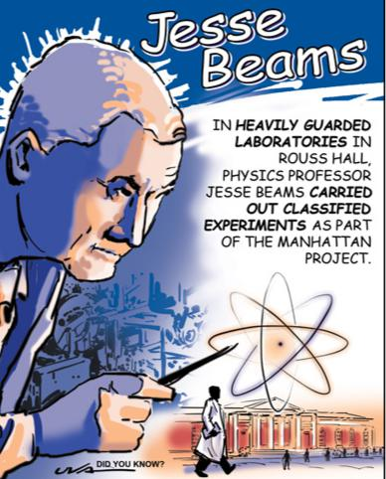
UVa and the Manhattan Project

Carefully protected research related to the war effort had been carried on in various laboratories at UVa since late 1941. The labs were guarded around the clock by armed members of the Virginia Protective Force, and later by men in less conspicuous civilian attire. Such researches and experiments would continue, on an expanded scale, throughout the conflict.

Part of the research on the atomic bomb that devastated Hiroshima and Nagasaki was done at the University. Jesse Beams’s ultracentrifuge played a significant role in separating the uranium known as U-235 from U-238 and U-234. Dr. Beams had been a member of the original five-man committee appointed to study uranium fission under the National Research Council. After the University’s physicists concluded their wartime work on uranium in the Rouss Laboratory, they turned their attention to the development of guided missiles and were equally successful.

More on Beams’ Secret Experiments

Completed in 1898, Rouss Hall was built to house classrooms and physics laboratories. Just over four decades later, those labs were the site of top-secret experiments conducted by physics professor Jesse Beams—experiments that would help usher in the nuclear age. Beams, the head of the physics department from 1948 to 1962, was one of five scientists appointed by the National Research Council to study uranium fission before the United States entered World War II. After Pearl Harbor, the effort grew significantly in scope and became the Manhattan Project—the code name given to the U.S.-led efforts to develop an atomic bomb.

Work at the University focused on the use of an ultracentrifuge to isolate uranium-235 from U-238 and U-234. Developing centrifuge machines that created forces more than a billion times that of gravity, Beams was successful in his efforts—though his method was not used in the actual manufacture of atomic bombs. The ultracentrifuge did have other practical research applications, such as separating viruses and other biological forms from their carrying media.

Beams worked on the Manhattan Project with a team of carefully selected students and faculty. One of whom was Frank Hereford, the University’s president from 1974 to 1985. He worked closely with Beams and was a prized student; Beams described him as “one of the best all-around physicists with whom I have ever been associated.”

What happened after Japan’s surrender?
When news that Japan had surrendered hit Grounds in August 1945, there was wild jubilation. “The Corner was jammed with everybody yelling and waving and waiting to see what everybody else was going to do,” Bill Lyle wrote in College Topics. But despite the exultation, bulletins continued to come in from Europe and the Pacific concerning the missing and the dead. These appeared for months in the Alumni News, which during the war had carried thousands of items concerning the men in the service, their experiences, heroism, and decoration.

Demobilization of the men in the armed forces proceeded steadily during the winter and spring, and by September 1946 the veterans were pouring back into the colleges and universities. Enrollment at the University of Virginia was 40 percent ahead of the largest previous figure, that of 1939-1940. A total of 4,204 had been registered by early fall.

How did the influx of war veterans change the climate of the University?

Many of those enrolling were war veterans seeking an education under the GI Bill. The problem became that these men were not as interested in the Virginia tradition as they were in getting their degrees. Consequently, there was a continuation of the serious academic culture which emerged in the War, paired with a profoundly different social organization. Many students were married, for example, resulting in a dramatic increase in enrollment. Immediately after the War, a rift existed between veteran and non-veteran students. Consistent with national trends, veteran students scored higher marks than their non-veteran counterparts. Still, there were some areas in which students of all backgrounds were able to find common ground. Memorial services for the University’s 321 war dead were well attended, and the U.S. Naval units at UVa, the Alumni Association, and the class of 1945 collectively dedicated a memorial cross and candlesticks for the chapel. So they showed remarkable unity in their support of the just completed War. Also, many students wanted to find guarantees that the peace recently won would last.
McCarthyism and the Cold War

The rising tide of anti-communist sentiment and the “outbreak” of the Cold War were overshadowed by the Korean conflict and the draft in University students’ lives. Simply, the real possibility of being drafted and having to fight weighed heavier on the minds of students than the more distant fervor Senator McCarthy and cohorts were creating in Washington. In some respects, McCarthyism was to the faculty what the draft was to the students--a force with life altering power.

McCarthyism seemed like just another folly of ungentlemanly bureaucrats. However, no communist affiliated groups existed in the 1950s at the University as in the 1930s; had one, it surely would not have been met with the openness towards the liberal groups of twenty years before. The series of events commemorating the 125th anniversary of the opening of the University to students was opened by a three-speaker debate on the question “Do we Have an Alternative to the Cold War?” Students clearly were interested in the maintenance of peace, but the climate was not sympathetic towards pacifism. Some students likened the hysteria over communism to a witch-hunt—people were getting worked up over little real threat. McCarthyism in particular simply required “sticking one's neck out”, an unappealing posture for the conservative, coat-and-tie clad Virginia gentlemen. While the University's strong sense of tradition kept most students from becoming champions of liberal causes in the thirties, it also restrained conservatism in the 1950s.

Citations for WWI, WWII, and the Cold War:

Dabney, Virginius. Mr. Jefferson's University: A History. Charlottesville: University Press of Virginia, 1981. Hitchcock, Susan Tyler. UVa: A Pictorial History. Charlottesville: University of Virginia Press, 1999. Stambaugh, John. 100 Years of Life on the Lawn Project. “Students, Traditions and Wars: The Middle 20th Century at UVa.” 1997.

Kennedys discuss the Cold War at UVa

From “Kennedys Attend Law Day” in Alumni News, 1958

The Law Day, planned as the first of an annual series, was a grand success. There were 619 Law School alumni and students who went to the buffet dinner in the Memorial Gymnasium. Other students, sitting around the balcony track, swelled to more than 800 to hear the address by John. F. Kennedy, the Massachusetts Democrat. Ted Kennedy was a second-year student of law at this time.

Senator Kennedy spoke first of America’s “lag in educational achievement,” then speaking more directly to the lawyers he said that his committee work in the Senate has brought to his attention an “insidious form of infection which is peculiar to our legal profession” as the result of which “a lawyer who is exerting his best efforts on behalf of his client finds it easy to justify conduct which he would immediately recognize as improper if he were acting merely on his own behalf.”

Discussing education and the “Cold War” Senator Kennedy said “it is no exaggeration to say that the struggle in which we are now engaged may well be won or lost in the classrooms of America.”

May Days: The Vietnam War Protests of May 1970

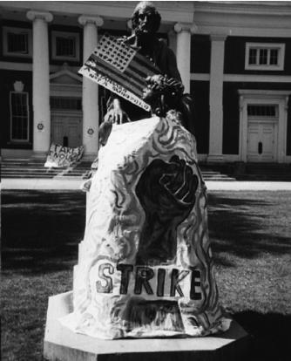
Why were the years of Shannon’s reign considered a “boiling point”?
President Darden has been publically critical of fraternities, which sparked mild student protest. But the most vehement protesting would be reserved for his successor in 1959, Edgar Shannon. In addition to Civil Rights protests (mentioned later) throughout his tenure, student tensions due to the Vietnam War came to a crux in May 1970. Pictured right is the Homer Statue during May Days in 1970.

How did the students express their pacifistic leanings?
For several weeks in May of 1970 called “May Days”, anti-Vietnam sentiments besieged the University and transformed the Lawn from a peaceful place into an arena of protest. Students around the nation were anxious “not so much for my own life, as for the existence of men on earth” according to one student in the 1971 Corks and Curls, and they were increasingly angry. After hearing of the tragedy at Ohio’s Kent State University, on the evening of May 4, UVa students rallied at the Rotunda, and then they marched on Carr’s Hill, where they read to President Edgar Shannon the telegram that they had addressed to President Nixon. Shannon offered sympathy, but he refused to give his signature to the document.

Next, the mob traveled to Maury Hall, the Naval ROTC building, seeking to take over the building. The College’s President and Vice President blocked the doorway until the demonstrators pledged their commitment to non-violence. An injunction ordering evacuation was soon issued, and the police arrived at 4:30 a.m. The building was vacated, but the still large gathering returned to Carr’s Hill, where they demanded to see President Shannon. Mrs. Shannon, assuring the students of her husband’s absence, persuaded them to leave, and the evening’s activities were finally finished. A Strike Committee was then formed, which worked for a boycott of classes. 29 of UVa’s 33 fraternities endorsed such an action, as did about 150 faculty members. On May 6, some faculty did not even hold classes, though there was no official cancellation.
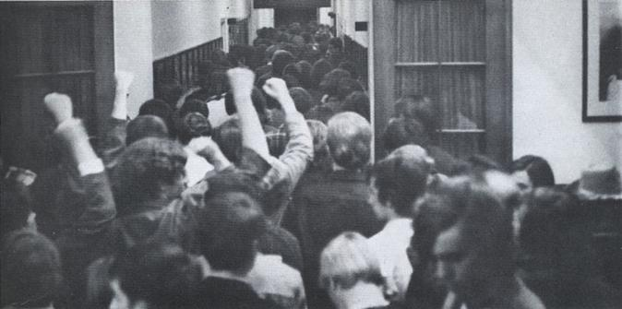

Hundreds of students occupying Maury Hall (home of the ROTC)
How did the University respond to the riots, and how did President Shannon transform into a student ally?
On one night in May of 1970, students gathered on the North side of the Rotunda. Charlottesville’s Commonwealth Attorney invoked the Riot Act. 67 people were arrested, many students. According to some sources, police even entered Lawn rooms in pursuit of protestors, and those taken into custody included innocent bystanders and a pizza deliveryman. Though the arrested were released immediately on bail and the charges soon dropped, outrage filled the University community.
History of African-Americans at UVa
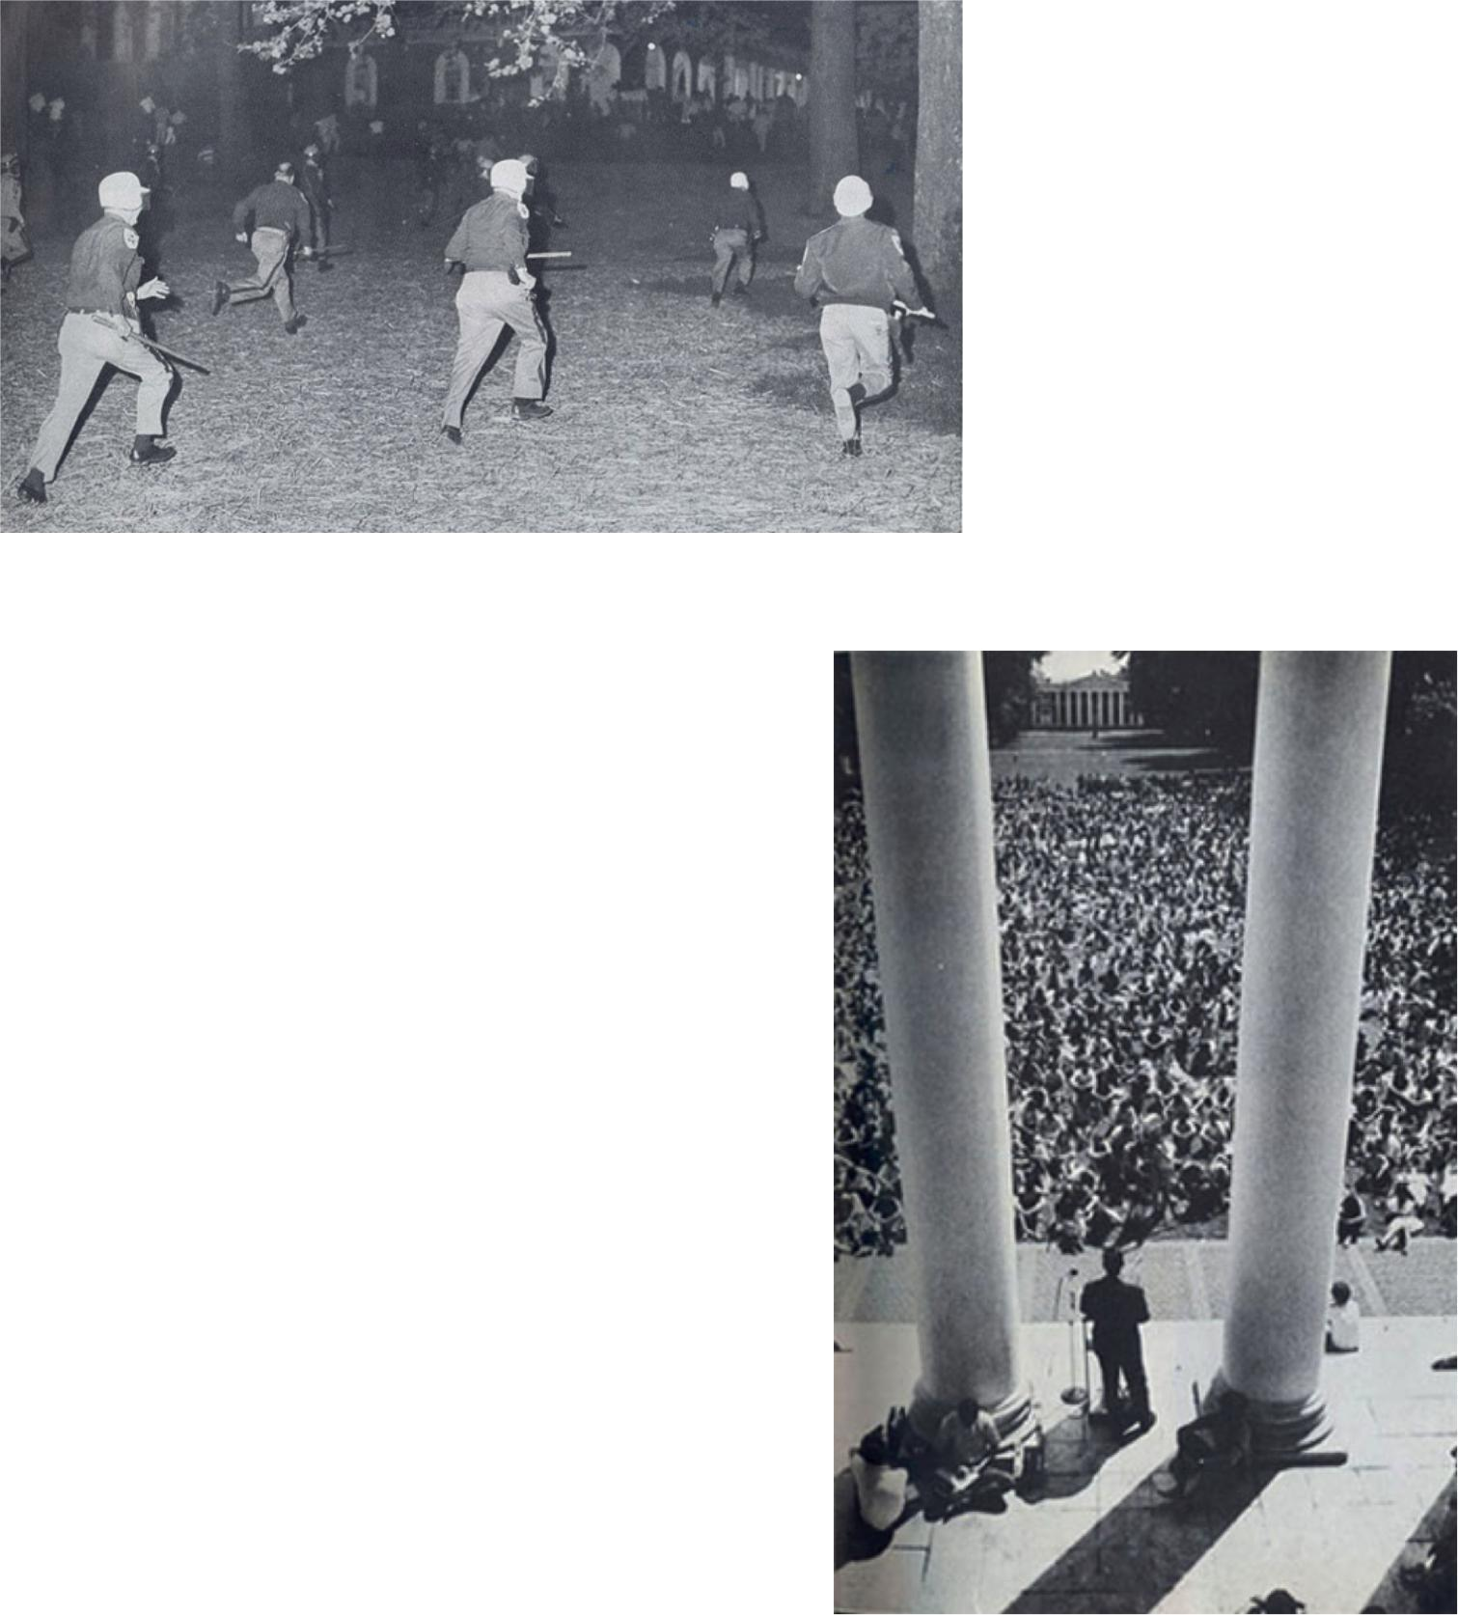
A rally near the Lawn results in the arrests of 68 people, including students and faculty.
On May 10, Shannon again addressed the student body. According to the Cavalier Daily, he pledged to continue the University’s free speech, even in “an absolutely dangerous and frightening situation.” His speech concluded with a condemnation of the invasion of Cambodia, drawing cheers from his audience. He presented a letter, which he pledged to send to Virginia’s U.S. Senators.
Throughout the turmoil, no classes were officially cancelled or suspended, but allowances were made to facilitate student protest. Finals were made optional, and students were given the option to, instead, accept as final their grades up to May 1, to take exams the next semester, or to substitute work for the requirement, due by June 1. At Final Exercises, President Shannon received a standing ovation, and by the fall term, the University had quieted considerably. Few, however, who had been present during those weeks in May 1970, would ever forget the temporary transformation of Mr. Jefferson’s University.
President Shannon delivers an anti-war message to an audience of 4,000 on the Lawn.
Citation: “Protest: A History of Unrest at the University.” UVa Alumni News. Fall 2002.

As long as history itself is relevant, so will be the history of African-Americans, because they are one in the same. If “those who cannot remember the past are condemned to repeat it”, then this information still has relevant implications for matters of diversity today. (This section focuses on post-Civil War.)

Note: this information is always evolving as research efforts expand.

Post-Fire Reconstruction and the Venable Lane Community

What was the Venable Lane Community?

This was a community, located behind what’s currently Cabell Hall, founded by a former slave, Katherine “Kitty” Foster, in 1833. Foster and her daughters cleaned clothes for students and faculty, and her sons worked for nearby craftsmen.

She purchased the property for the Venable Lane Community from local merchant John Wynn. The property develops into a predominantly free black, working-class community. By the late 1800s, the land is nicknamed somewhat derogatorily “Canada”, referring to the idea that though the land is nearby, it’s very different from the rest of Albemarle County.

How did the new additions to the Lawn affect the community?

In 1898, Stanford White’s additions to the Lawn (Cabell, Rouss & Cocke) effectively and intentionally closed off the Lawn to the Veneable Lane community. (Also, the nude female figures seen on the pediment of Cabell were crafted from a black prostitute from a bordello, because sculptor Gyula Zsolnay considered that no “respectable white woman” would sit as a model.)

How do we commemorate the community today?

After Kitty’s death, her family sells the land in 1906 and it becomes a majority white community. UVa purchases the land in 1976, and in 1993 finds twelve grave markings there, likely the Foster’s. Twenty more graves were found during construction of the South Lawn, and a grave memorial for this community is established, showing indentations over each plot where a grave was lain. The memorial also includes a metal “shadow catcher” to cast a shadow in the form of Foster’s house site, and a plaque commemorating the Foster family.

First Applicants and Students

The South Lawn memorial is a testament to the changing nature of the University over the years. But this change would not have been possible without the pioneers/trailblazers who begin to change UVa forever in the mid-20th century.

Who was the first African-American to apply for matriculation into the University of Virginia?

In 1935, Alice Jackson-Stuart applied for her Master’s in French. The Board of Visitors denies her for “good and sufficient reasons”, sending her a letter stating that the “education of white and colored persons in the same schools [was] contrary to long-established and fixed policy of the Commonwealth of Virginia”. (The BOV letter and her appeal can be seen in the Special Collections library to this day.)

In 1936, the state legislature established a system where the state would pay the tuition of African-American students qualified for UVa, but unable to attend because of their race—essentially using the Plessy v. Ferguson “separate but equal” philosophy to justify this policy. This sends more students to black colleges in Virginia, but merely under the guise that these universities can offer the same/equal caliber education.

The NAACP determines Jackson-Stuart’s case too weak to pursue, so she attends Columbia University instead (on the University of Virginia’s dime).

What else sparked racial tensions at the University before integration?

On October 11, 1947, Chester Pierce, a black football player for Harvard, played against UVa.

Who was the first African-American student admitted?

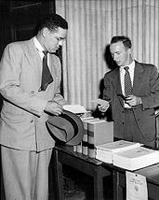
In 1950, Gregory Swanson, a black graduate of the law school at Howard, decides to apply to UVa Law after practicing for two years, exploiting the 1936 legislation loophole because there is no other law school for African-Americans in the state (or engineering or medical school, for that matter). The BOV rejected him as well (believing his admission would be breaking Virginia law), but this time the NAACP and Thurgood Marshall help him sue/appeal. The NAACP led a series of court cases after the “separate but equal” doctrine was declared unconstitutional in 1950.

The U.S. Circuit Court of Appeals tells the BOV that “refusal to admit Swanson cannot be successfully defended in court”, given that he was an extremely qualified candidate who was already a practicing lawyer. Thus, he becomes the first African-American granted admission to UVa. Desegregation officially begins.
Gregory Swanson matriculates to the UVa Law School in 1950

What was Gregory Swanson’s experience like at UVa?

He dropped out in the summer of 1951 due what he described as an overwhelming climate of racial hostility and harassment from both students and faculty. (He was forced to take residence off-Grounds, not allowed to join a fraternity, and at every football game had to endure students yanking out the Confederate flag before singing the Good Ol’ Song.) He left hoping that at least his admission would open the door for other blacks, but felt that University students did not reflect the true spirit of Jefferson because they did not care about racial equality or the welfare of the country.
Who were the next two African-American students to attend UVa?

In 1951, validated by Swanson’s entry, Walter N. Ridley and Louise Stokes-Hunter, both faculty members at Virginia State University, enter UVa. Their admission was particularly significant because it came three years before the landmark Brown vs. Board of Education decision that desegregated schools.

In June 1953, Ridley becomes not only the first black to gain a degree of any kind at the University (he gets his PhD from Curry), but also the first black to earn a doctorate at a major southern university. Throughout his time here, Ridley received excellent marks, and later graduated with high honors. He’s quoted as saying, “If anyone gave any sign that I was not welcome, I was not conscious of it.” Whether this is truly reflective of his experience we do not know. However, he was not invited back to the University until the first Black Alumni Weekend in 1987; at which a UVa scholarship fund was named in his honor. Today the multi-million dollar Ridley Fund provides alumni funded scholarships for African-American students.

In August 1953, Stokes-Hunter becomes the second black person and first black woman to gain a degree at the University, also earning her doctorate in education.

Who were some of the first black undergraduates at UVa?

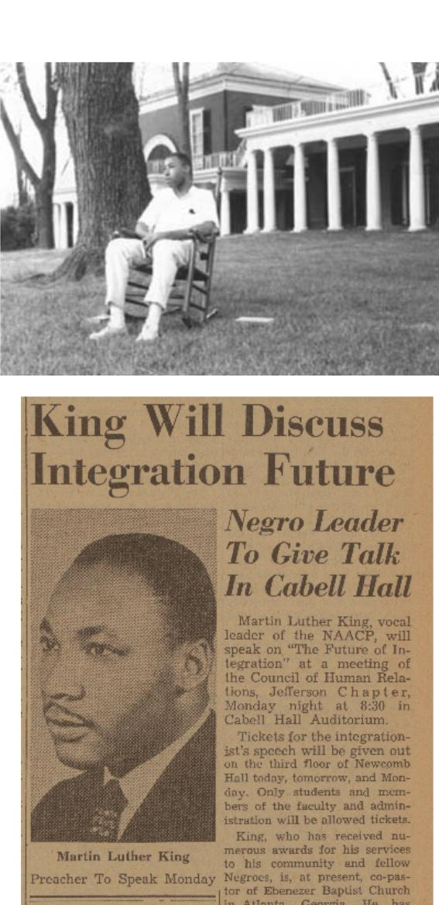
In 1955, Robert Bland, George Harris, and Theodore Thomas made history by entering the University’s undergraduate engineering program, but soon found their efforts to receive a degree exhausting. Alienated from their classmates, the three men studied and socialized together. Harris and Thomas transferred at the end of their first-year.
Leroy Willis, the first African-American to live on the Lawn; The Cavalier Daily, March 1963

In 1959, Robert Bland becomes the first black undergraduate to graduate from UVa, earning his degree in Electrical Engineering. He referred to his time as a “struggle” and “mostly academic”, saying Charlottesville itself was more welcoming than the students or professors. Even so, “Bobby stayed” became a popular phrase among black students who later attended the University in the 1960s and faced racial hostility. (Bland is still alive; that’s how recent this history is.)

Who was the first undergraduate to NOT attend a specialty school?
Despite the passing of Brown v. Board on May 17, 1954 to desegregate “with all deliberate speed”, blacks in Virginia were still only admitted to specialty schools like engineering because of the state’s continued adherence to the “separate but equal” doctrine—as long as black colleges existed, admittance to UVa’s College of Arts and Sciences could be denied.

A. Leroy Willis originally entered UVa as a Chemical Engineering major, but sought to transfer into the College to study Chemistry. The Chair of the Chem-E Department

suggested he transfer schools entirely and instead enroll at Virginia State University, a college for “your people” as the Chair put it. He rallied support and quietly transferred to the College in 1960, becoming the first African-American student (and eventual graduate) from the College of Arts & Sciences. He also becomes the first African-American to live on the Lawn, and a plaque in 43 West exists in his honor.

By 1960, there were at least 25 black undergraduates in attendance at UVa for the first time.

Which University students became activists on Grounds?
Wesley Harris entered the University with Virginius Thornton in 1960. At a time when the University administration seemed resistant to change and when fellow black students left in utter frustration, Harris and Thornton were determined to make a statement. They became activists around Grounds and Charlottesville, picketing restaurants that did not serve blacks and staging sit-ins. (UVa was the only school in the country that held demonstrations or marches in coats and ties.)

Harris became a member of the Thomas Jefferson Council on Human Relations in Virginia eventually moving up to the chairmanship. An interracial array of faculty and students, the committee was dedicated to addressing race issues at UVa.

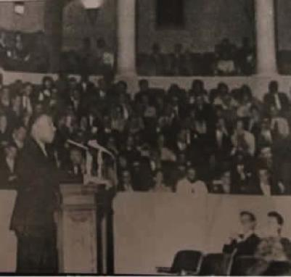
On March 25, 1963, Harris coordinated Martin Luther King Jr. to come speak at Old Cabell Hall to 900 students (only one professor attended) through the Jefferson Council. From 1963-1964, he becomes the second African-American to live on the Lawn, the first man (black or white) to complete the Engineering Honor program, and the first black initiated into the Jefferson Literary and Debating Society. Today Harris is an Associate Provost at MIT.

Although some black alumni mention some of their goals then were to show white faculty and students what in fact they could do at the University, Harris was intent on showing black people what they could do. “To convince black folks, not white folks, but blacks folks, that in a hostile environment they could achieve academically,” he said. “And to the highest level not just messing around getting a “D” or “C” or getting out of the place, laughing and shucking and joking. But to achieve, to be a senior stellar scholar.”
Dr. Martin Luther King Jr. speaks at Old Cabell Hall

Who was the first black faculty member at UVa?

Nathan Johnson is hired in 1967 and taught at Curry for many years. (He had previously himself received his doctorate from Curry.) Hereford Residential College’s Johnson Hall is named in his honor.

How had opinions shifted by the end of the 1960s?

At the end of the decade, the change in the mindset of black and white students alike would be demonstrated in the election of the first black Student Council President James Roebuck in April 1969, selected by his fellow Council members. (Roebuck became instrumental in consulting with Shannon before his historical 1970 speech denouncing the Vietnam War and promoting racial equality.)

Activism in the 60s & 70s

What action was the University taking by the late 1960s?
After the assassination of MLK, Jr. in 1968, President Edgar Shannon meets with a group of black students. where they recommend actively recruiting black students, hiring more black faculty (including a black admissions officer), and introducing a Black studies program.

In November 1968 President Shannon commissions a committee whose goal is to increase the enrollment of African-American students in all schools at the University. (The total African-American population at UVa at the time is only 0.4%.) In autumn 1969, the University opens its doors to black males in all schools. Elizabeth Johnson becomes the first black admission offer, and is recruited to help the University raise its percentage of matriculating black students.

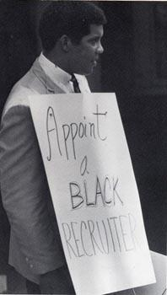
Also in 1969, black students begin an organization called Black Students for Freedom (called the Black Student Alliance today), and Black Studies becomes an official major at the University. By 1970, after aggressive minority recruitment, about 117 students (1.8%) become members of the UVa population, a significant increase.

When was the first “Black Culture Week”?

The Black Students for Freedom puts on the first “Black Culture Week” in February 1971 in order to celebrate the uniqueness and pride in being black. Guests include civil rights leader Julian Bond, author and poet Nikki Giovanni, and actor and activist Ossie Davis.

How did the University address racial discrimination?

Student Council begins demanding that the application fee be made optional for low-income students, that an application photo be made optional, and that UVa stop sending recruiters to secondary schools that discriminate. In 1971, the University decides to no longer accept funds from racially discriminatory scholarships.
In 1973, Student Council President Larry J. Sabato demands that the University administration and faculty who have memberships at Farmington Country Club withdraw those memberships, as Farmington maintained a strict segregationist policy for its members.* President Hereford resigns from Farmington in 1976. (Note the role reversals compared to the University’s beginnings, when students were largely pro-slavery compared to their European professors.)

What organizations became available for black students?

Fraternities become integrated in 1969. Black fraternities and sororities begin to draw incredible interest from black students in the 1970s. About 29% of black undergraduates pledge these organizations by July 1974.

In August 1976, the University officially establishes the Office of African American Affairs and a Dean of African-American Affairs (William Harris Sr., the twin brother of Wesley Harris), in response to student pressure, primarily from the Black Student Alliance and Student Council. President Hereford, a Farmington member, was not in attendance at the open forum. In 1981, again from pressure from the BSA, the Carter G. Woodson Institute for African-American Affairs is founded (currently located in Minor Hall).

*Random: Sabato is also responsible for convincing the BOV to build a new library… When the BOV was coming in to tour the libraries, Sabato got tons of students to pack in Alderman to convince them we needed more space. The result? Clemons.

Who is the first African-American to speak at Final Exercises?

On May 21, 1978, Thurgood Marshall, associate justice of the U.S. Supreme Court, speaks at Final Exercises and gives this famous quote: “The privilege of attending so fine a university as this one must bear with it an unceasing responsibility to use your knowledge and training for improving the lives of others.”

Current Issues and Progress

Why are there Black Z’s seen around Grounds?
In 2003, two individuals assaulted Daisy (Lundy) Lovelace, a half-Black half-Korean student running for Student Council President, near the lawn. She is still elected, however, and the black Z’s seen around Grounds today (OCH steps, Madison Hall) are a community response of support.

What grievances do the BSA still have against UVa today?

- Concerns over losing a community with a growing population and difficulty in bringing everyone together under one cause

- Honor biases against African-Americans

- The African-American studies program is interdisciplinary, and not its own department (which affects faculty hiring, giving AAS professors tenure, and limits funding and general academic prestige)

- Frustrations over the money required to run in student elections

- Lawn selection undervaluing “ethnic” activities and groups

Who was the first African-American family to live in a pavilion on the Lawn?
From 2000-2005, Beverly Harmon, the Assistant Dean of Students at the Law School, and her husband, Senior Vice President for Development, lived in Pavilion III. They were known as being well-liked and extremely close to the community.

But what highlights does UVA have today?

- UVa has maintained the highest graduation rate for Black students in public universities (approx. 86%) since 1995.

- The numerous opportunities for black students in the hundreds of CIOs

- Issues of race and inequality are increasingly talked about (e.g. Sustained Dialogue and EDLF 5000: Multicultural Education)

- Student Council Committee on Diversity Initatives, and the push for a Memorial for Enslaved Laborers

- George Keith Martin, a graduate of UVa, became the first African-American Rector of the Board of Visitors in 2013.

Conclusions for an HAA Tour
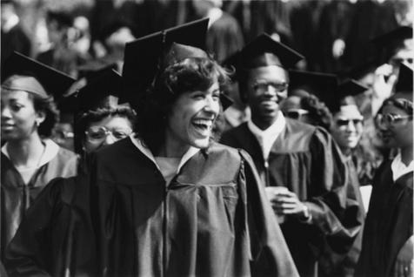
Think about what you’d genuinely want an audience to take away from a tour or stop on this information.

Concluding an HAA is really difficult. All guides struggle with how to craft a conclusion that does not come off as “and now it’s all better”. Here are some tips for figuring out how to craft your own HAA conclusion.
- Be careful with ending an HAA on

Jefferson. Yes, his ideas of an institution that valued the “illimitable freedom of the human mind” and one that would progress towards a more perfect truth are applicable. But Jefferson also was a slave owner and believed that blacks were inherently inferior to whites. Be thoughtful about how you integrate discussion of Jefferson. In the end, this is not a tour about Jefferson’s interactions with black people. It’s a tour about the history of African-Americans at UVA. Be sure to tell their history, not Jefferson’s.

- “What I have always loved about this University is its capacity for change” – Robert Williams, 2nd UVa Law School graduate
- Consider a quoting a black alumni or faculty member (there are several quotes in the sections above)
- Mention that the history of African-Americans is still being written, and that the “black experience” at UVA is continually evolving
- Sometimes you can’t wrap a tour up nicely in a bow. Be OK with the ambiguity, and encourage your tourist to think about that ambiguity.
- Be yourself. Talk about why you want to tell the history of African-Americans and why you signed up to give the tour.
- Ask for stories and opinions. We’re still working on these tours and we know that we have room to improve.

Remember, if you ever have questions or concerns, talk to your Probie Chair, the Historian, the Specialty Tours Chair, or your big guides. They are all more than willing to help!

“Desegregated….but not Integrated”

Adapted from Gemela Noelle McClendon’s Desegregated but not Integrated: African-Americans and the University of Virginia, 1968-1974 & compiled by Mary Talman, Kimber Shoop, & Peggy Boutelier

The integration of the University of Virginia has been a slow process, as evidenced by the fact that 16 years elapsed between the admission of Gregory Swanson (1950) and the active recruitment of black students in 1966. While reverence for tradition has often kept the University from moving quickly on issues, during the decades from 1965 to 1985 UVa was able to make changes that enabled it to confront long-standing racial traditions and which enabled the University to serve a more diverse community.

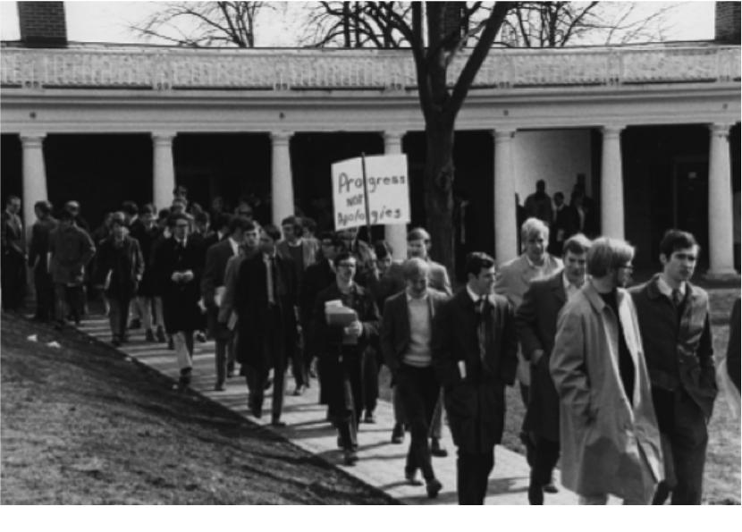
Why are the academic years of 1968-69 and 1973-74 called a period of transformation?

During this era, academia began to recognize UVa as an excellent institution for scholarship and research; the athletic department began to receive notice from sports enthusiasts around the world, and, most importantly, the University slowly began to move away from its elite white male tradition in education. Women would become 50% of the undergraduate class and African-Americans would enter the University in numbers never seen prior to this era, despite the University’s official “anti-segregation” policies.

Protest against racial inequality on the Lawn, 1969

Who provided the impetus for the increased recruitment of African-Americans?

Between the years of 1960 and 1970, the number of students enrolled in the University rapidly increased. These new students, more often than not, ranked in the top percentiles of their high school classes and had participated in a variety of extracurricular activities prior to their coming to UVa. Hailing from a variety of backgrounds, these students began to question those things which had been “previously regarded as immutable.” At U.Va, this questioning would lead to, as Virginius Dabney termed it, the “Passing of the Old University” in 1968 and eventually open the door to the true desegregation of the University of Virginia. The student-body soon cast away the ideologically conservative beliefs of their predecessors and adopted the liberal ideology of their generation. By 1968, Vietnam, integration, and women’s rights became major topics of concern.

Some observers, such as Student Council President Arthur “Bud” Ogle, attributed this move to the death of Dr. King. Bud argued that this opened students’ eyes to the need for a real change, and it would be the Virginia students who led the faculty and administration in taking proactive steps to fully desegregate the University.

What demands did the student body make of the administration to improve the black experience?

The minute African American student body and the Student Council drew up a petition which was signed by over 2,500 University students during the academic year of 1968-1969. These demands read:

- The active recruitment of qualified African American students

- The hiring of a black admissions officer

- The hiring of black faculty and administration

- The establishment of African and African American studies courses.

- Money for the Martin Luther King Scholarship

- A mandatory pledge against segregation that must be signed by all off-grounds housing providers

- The re-evaluation of admissions criteria to correct for racially and economically biased college board examinations (i.e. SAT’s)

- The active involvement of high schools in the destruction of U.Va’s all white, elite image.

- The establishment of a special program to provide financial assistance to “culturally deprived students”

What else did the student body do to ameliorate the segregationist climate at the University?

On February 18, 1969, a coalition of students staged the first in a series of protest on the steps of the Rotunda against what they termed as the “racist atmosphere” at UVa. This protest called for the resignation of Chase Stuart Wheatley, a member of the BOV who was one of the creators of Massive Resistance, the plan which the Virginia Assembly adopted to prevent the integration of public schools in 1959.
Student Council voted unanimously that no Council recognized organization could use segregated facilities for any of their functions. Also, in the 1968-1969 academic year, the IFC moved to no longer recognize fraternities which maintained discriminatory clauses and bylaws within their constitution. And student run publications such as The Cavalier Daily took every opportunity possible to attack the University and its inactivity in regards to race relations, going so far as to liken the University to a hippopotamus “wallowing in its whiteness”.

More conservative members of the student body staged what the Richmond-Times Dispatch would call “the coat and tie” protest after the radicals presented their demands to President Shannon. These protestors agreed with what the more radical group of protestors called for, yet disagreed with their methodology. In their view, change could be affected without disregarding tradition and without condemning the University’s officials. Other groups such as the Z Society simply pledged their support to the University in its move to integrate.

Which three institutions continued to push for full integration post-1968?

- Black Student Alliance: The BSA continued to vocalize its dissatisfaction with race relations and the “unnecessary hardships” faced by African American students at the University long after the 1968-1969 school year. For example, in 1972, The BSA drafted a letter entitled “Directives and Proposals to the President and the Board of Visitors” calling for additional black faculty, an effective minority recruitment plan, a fully funded black studies program, and an alleviation of the “pressure and psychological strains” black students face in attending a school within an all white environment.

- The Cavalier Daily: In 1968, the CD took a militant stance against racism at the University. In fact, the biting commentaries and reports made by a staff of almost all white writers prompted Student Council to action in 1969. And in the years between 1968 and 1974, The Cavalier Daily often dedicated a section, if not almost a whole paper (such as the March 23, 1970 issue), to the issues surrounding African American integration and life at the University.

- Student Council: With its first black elected member, James Gay, in 1968, Student Council voted unanimously to forbid any Council recognized organization to use segregated facilities for any of their functions and decreed that any organization recognized by the Student Council could not discriminate against an individual due to their race. Student Council Presidents Arthur “Bud” Ogle and Larry Sabato also took very active stances on race relations at UVa. In 1970 Ogle blasted both the University’s administration and student body for the student body’s “unwillingness to pull together and accept fellow members of the community as brothers regardless of race, color, religion, national origin” and for the administration’s willingness to use quotas for women, yet not for African Americans. And in 1973, Student Council President Larry Sabato used his influence to request that all University faculty, staff, administration and students withdraw their memberships in the segregated Farmington Country Club, arguing that one’s private life could not be separated from one’s public dealings. He therefore felt that if a faculty member or administrator belonged to a segregated organization, it could not help but to affect their dealings with African American students.

How did President Shannon and UVa attempt to increase the recruitment of black students?

In order to recruit more blacks, the University had to not only accept more, but it also had to make the University more appealing to black students. The Admissions Office sought to achieve these goals through a program that sent a mixed group of Deans to speak to and actively seek out competitive black applicants at predominantly black high schools. The group of speakers was purposefully made heterogeneous in order to 1) express the positive experiences of blacks at the University, and 2) show that all members of the University community wanted them to attend the school. In addition, the admissions office also set out to create a pamphlet for the academic year of 1969-1970 geared specifically towards African American students.

Outside of the admissions office, President Shannon appointed the Rotch Committee to study methods of increasing the enrollment of African-American students in all schools at the University. The committee found that the number of African American students attending the University was low because so few African Americans applied to the University, either because they did not know of it or because they did not believe they could attend. The committee recommended the hiring of an African American dean of admissions who would be solely dedicated to the recruitment and retention of African American students and faculty, a suggestion which the University chose to follow when it hired Mrs. Elizabeth Johnson in 1969.

Was Shannon successful?

In 1968, African Americans only made up .4% of UVa’s total undergraduate student population, and by 1970, after the implementation of a more aggressive minority recruitment plan, this number increased to 1.8%, or 117 African-American undergraduates, 4.5 times the number in 1968. As black students and faculty made up more of a “critical mass,” they had more of an impact on the decisions and activities of the administration. However, the under-representation still led to discontent among black students. And when compared to other Southern universities, the University had the worst starting total for African-American enrollment, and by 1970, only ranked 9th out of 16 other universities. With this realization in mind, Shannon created an Afro-studies major and refused to accept funds from racially discriminatory scholarships. The student body had indeed sparked the movement towards integration, but the desire (whether sincere or not) of the administration to continue the process of desegregation is what kept the movement going.

But even after enrollment increased and demands were met, what was life actually like for black students?
In 1969, when the first group of black students entered the College of Arts and Sciences, the structure of the University could not successfully accommodate them. The long held doctrine of “separate but equal” had created an environment where the “education of white and colored persons in the same schools [was seen as] contrary to long-established and fixed policy of the Commonwealth of Virginia.”

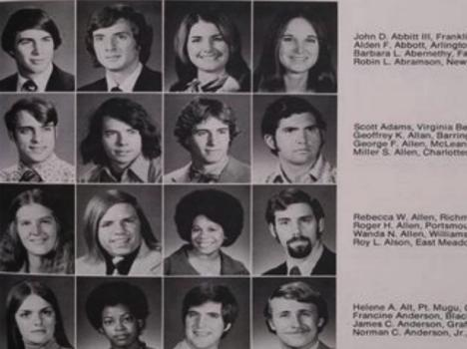
Though the Federal government and University regulations allowed African-Americans to participate in whatever activities they wished, culturally they often felt disconnected from the traditions and activities shared by the members of the white student body. African-Americans during this time period did join a number of traditional University student groups, including intramural sports, Pep Band, white fraternities, and Corks and Curls, to name a few. University students even elected African Americans to some of the highest student-held positions in the University.
Issue of Corks and Curls, 1970, illustrating the increased diversity of the student body

These students were enrolling in a University where their white peers regularly displayed Confederate flags and blatantly racist imagery and quotations, such as those found in the 1970-1971 edition of Corks and Curls, could still be found gracing the pages of student publications. And some African Americans encountered open hostility from professors and students in Virginia classrooms.

Did self-separation become an issue because of this?

Even in 1974, after black students had begun to be admitted in ever increasing numbers, the University was still perceived as “limited, conservative, elitist, and racist.” One African American student remarked, in this same year, that the black experience at UVa was “shallow, because the whole system of traditions is oriented toward the white population of the University.” Black students, according to African American alumni, simply would not have felt comfortable joining white organizations because they did not see these organizations as being relevant to their experiences and they did not believe their voices would be listened to if they chose to join. Additionally, African American students felt “that since there were so few blacks on Grounds, they had best stick together and not join “white” organizations, for they needed to have a united voice in order to achieve those rights and opportunities which they felt were not yet theirs.”

In light of the obvious discomfort African Americans felt when considering joining the University’s white student population, they began to form their own social organizations and traditions; they became a “family” and support system in and of themselves. As one alumna put it, the African American students needed to find “their own identity and sense of belonging.” Black students at the University between the fall of 1968 and the spring of 1974 also began to develop or charter several organizations to suit their own cultural and social needs, which culminated in BSA’s creation of Black Culture Week. Other groups started at the University by African American students were chapters of the four prominent historically African American fraternities and two of the historically African American Sororities. Almost 29% of the undergraduate black student-body was pledging these organizations by July of 1974.

When and why was the Office of African-American Affairs (OAAA) created?

Since the 1950s, Black Students on grounds had been asking for a representative in the administration-someone to advocate for them and give them support in navigating UVA, a fundamentally white institution. In 1975, the Black Student Alliance called for an Office of African Americans Affairs (OAAA) to be operational by 1976. Unsatisfied with President Hereford and the University’s response, three hundred black students marched to the President’s Carr’s Hill residence to demand a functional minority affairs advisor. After this, President Hereford promised that the University would begin addressing Black concerns. The Office of African-American affairs was established in 1976 “temporarily” at number 4 Dawson’s row. (Dawson’s row was originally commissioned in 1835 by Martin Dawson to be used as “Negro quarters”. These buildings were later donated to the university, and were used to house confederate soldiers during the Civil War).

OAAA officially opened on March 4, 1977 under the leadership of its first dean, Dr. William Harris (twin brother to Wesley Harris). In October 1977, 250 persons attended the Luther P Jackson House’s official dedication as the Office of African-American Affairs and Black Culture Center. During the “Harris Era” of the 1970s and 80s, the LPJ house was repeatedly racially vandalized. Dean Harris often allowed these vandalizations to remain for several weeks as a graphic reminder of “the kind of shabby business that sometimes occurs at this university.” Irrespective of difficult circumstances, the OAAA extended services to increased Black enrollment and graduation rates.

Dr. Paul Puryear succeeded Dr. Harris as OAAA Dean in August, 1981. Though the BSA opposed his appointment, seeing him as a “yes man to the white power structure”, OAAA expanded its offerings and services in a time of “unrepentant conservative elements at UVA”. Dean Puryear resigned in April 1986, following which the African-American community became suspicious that a successor would not be hired nor the Office continued. Anxious about the retention of OAAA’s academic, cultural, and social services, students painted “Save The LPJ House” on Beta Bridge. Legend has it that Jesuit priest Father Joseph A. Brown, at the time an English and religious studies professor, appeared unannounced at Madison Hall and Carr’s Hill to volunteer his services as OAAA Dean in June 1986. Father Brown served as interim OAAA Dean during the next two years. Dynamic and innovative, Father Brown often addressed board of visitors meetings, and advocated faculty enrollment in multiculturalism seminars.

Dean Brown was followed by Dr. M Rick Turner in 1988. Dean Turner recruited Associate Dean Sylvia Terry, and with her instituted the OAAA Peer Advisor Program in 1989. Since its creation, the Peer Advisor Program has served as national model for Peer-to-Peer advising, and has been a key component of retention of African-American students at UVA. Dean Terry is quoted saying “all of us know that what happens during the first-year affects whether a student chooses to remain or stay at an institution. For many, the Peer Advisor Program helps them to stay.

Since the early 90s, OAAA has undergone many modifications. For example, in the late 90s it served briefly as an umbrella organization for all minority affairs advising. In recent years, OAAA has been lead by Dean Maurice Apprey, and Associate Deans Kimberly Bassett and Patrice Grimes. Without a doubt, OAAA is an “indispensable cornerstone” of UVA. Its work and contributions paved the groundwork for all minority groups on grounds, and it remains today as an incredibly important resources for African-American students. In thinking about tours, OAAA is one of the key results and drivers of change between 1970 and 2000. So was integration achieved, or simply desegregation? Integration, as defined by Webster’s II New Riverside Dictionary, is to “make into a whole by bringing parts together” If this is in fact the case, one would have to conclude that in between the academic years of 1968-1969 and 1973-1974, the University of Virginia failed to integrate. Instead, they merely desegregated or abolished segregation from the University’s Grounds. African Americans, once confronted with the realities of a University not designed for them, had to design their own worlds in which they could feel at home.

Undeniably, the University’s desegregation was a resounding success. Between the falls of 1968 and 1973, the African American population at UVa had increased over 20 times, and African American students were slowly becoming a permanent part of the University’s landscape. Both students, faculty and administration were sensitive to the need for an African American presence at the University, and did almost all that was possible to bring blacks to UVa. But a greater goal was missed by the University in its move to desegregate. The University had failed to make African Americans actually feel welcome at the University and subsequently, it failed to unite the African American student-body with the white student-body.

Could the University have done anything to rectify this situation? Possibly, but more than likely not. True integration requires the willingness to learn about and accept difference between individuals; it requires open minds and hearts, something which cannot be regulated by Honor Codes and judicial bylaws. It requires more than the efforts of those who hold the scepter of power; it requires the effort and commitment of the individual, something that the University of Virginia could not achieve between the years of 1968- and 1974.

Black Alumni Weekend

In 1987, the OAAA joined the Council of Black Student Leaders to host the first Black Alumni Weekend. Among the 220 alumni who attended was Dr. Walter Ridley. This was the first time in thirty-four years that the University had officially invited him to return since his graduation in 1953. Since then, Black Alumni weekend has continued as a bi-annual event to promote and foster the Black community at UVA. This year, it is being held from April 10-12.

The Struggle for Integration with a Modern Perspective

The Dean of Students at the time, Robert Canevari, related a story about members of the University Union who were discouraged with recruiting a diverse group of students to become active in the organization. The students could not understand why blacks would not want to join the University Union. The Dean proceeded to ask these students if they had ever visited Luther P. Jackson House. The students replied negatively. When the Dean asked why, the students replied that they did not feel welcome there, at which time Dean Canevari explained how that was exactly the sentiment of most black students when considering student organizations such as the University Union. By understanding this simple truth, student organizations have been more successful in actively recruiting blacks for their organizations.

And today? The paragraph above was written in a time when all who were involved would agree that the University was struggling with integration. Are we still struggling today? If you asked different members of the modern student body the responses would be mixed, but it is important to understand that even now, in 2016, student organizations like the University Guide Service are still struggling to recruit minority members because of many of the same issues.
Examples of Civil Rights Protests at UVa

What led to Civil Rights protests?
The country was already experiencing great social unrest leading up to the 1960s. Brown vs. Board of Education in 1954 desegregated public schools and effectively yanked out the underpinnings of the South’s firmly entrenched Jim Crow laws, bringing race relations to the forefront of public awareness. By 1959, several black students had been admitted to the University, but only a few matriculated because they were reluctant to attend a school where they felt unwelcome. The few who came endured “venomous racial slurs.” But not everyone resented integration; many students, fed up with racism, began to protest for justice.

What events, related to the Civil Rights Movement, occurred at UVa?
In 1961, students boycotted the University Theater for its segregationist policies. Four years later, they marched down the Lawn in a “Sympathy for Selma” demonstration in support of civil rights marchers who were beaten by authorities in Selma, Alabama. On February 18, 1969, some 300 students, many wearing traditional coats and ties, convened on the Lawn for the first of three public demonstrations meant to “persist against racism” and call attention to perceived shortcomings at UVa. Among them: the alleged bigotry of particular members of the BOV and the absence of black representation on the board.

“We live and study in a male, upper-class, white, Anglo-Saxon Protestant ghetto,” said student Pieter Schenkkan. “We are ill-prepared psychologically to live in – much less lead- a nation and a world threatening to explode from the tensions of diversity.” In the wake of these protests, Shannon appointed a committee to study the issue of black enrollment, which recommended the creation of an interdisciplinary course in African-American studies and the appointment of a dean who would coordinate recruitment and retention efforts involving black students and faculty.

Even so, equality of treatment remained a thorny issue for many years. On April 28, 1980, about 100 black students gathered to protest the continuing inequalities they felt persisted at UVa. The group didn’t get the concrete response they were hoping for from the administration, so they staged a sit-in at Cabell Hall.
History of Women at UVa

In 1970, 450 undergraduate women arrived on Grounds as part of the University's first fully coeducational class. Although the UVa that they encountered was still very much a man's university, they were by no means the first women to make their mark here. Over the course of the preceding century, women had lived, studied, and worked at the University as professors' family members, summer students, graduate students, and members of the University faculty, staff, and Board of Visitors.

Although women were in the minority for much of UVa's existence, they actively participated in university life and influenced it in noticeable ways. Professor's wives and daughters, some of whom enrolled as students at UVa, enriched the community with social and service activities. Female faculty, staff, and Board of Visitors members helped shape University policies and served as respected advisors and beloved surrogate mothers to generations of UVa students.

Female students remained undeterred by the overwhelmingly male community that did little to welcome them. They found ways to make UVa their own - they ambitiously pursued their educational goals, established a separate student government, created their own places on Grounds, and formed lasting friendships with one another.

The cumulative impact of the University's early women, coupled with the energy and drive of the females in the first coeducational classes, enabled UVa to make the transition to coeducation swiftly and successfully. The school's rise in academic stature that accompanied coeducation proved to its proponents what they had believed all along - that the full presence of women at the University would only strengthen and enrich the institution.

Today, with women comprising fifty-five percent of UVa's undergrads, it is easy to forget that for much of the school's existence, females were in the minority. In highlighting just a few of the events, individuals, and experiences that form the history of women at UVa, this article reminds us all that 1970 was not too long ago (indeed, consider that many female dorm bathrooms today still have urinals in them) and that the legacy of these early women is too important to overlook.

Early History

Who were the original women on Grounds?
All of Jefferson’s glorious plans for his Academical Village were decidedly not for women. All students were elite, wealthy, white, and usually southern males. The only women at UVa were in professors’ families.

What was education of women like in the early 1800s?
Women’s education around the founding of UVa in 1819 was mostly general public education for the lower classes. The upper class could attend seminaries that taught manners, behavior, and basic academia. Jefferson himself designed a curriculum for his daughters and female relatives at Monticello. He believed education was important for the mothers and mistresses in the household, but the women were mostly taught music, French, and general reading.

How did things change throughout the 1800s?
During this time, women were still not permitted into most fields of academia. However, the Victorian Era brought in new desire to educate both sons and daughters, and this idea moved from England to the U.S. by the end of the century. Schools began to co-educate around the 1880s.

Turn of the Century

At the close of the 19th century, when approximately two-thirds of colleges and universities across the country provided coeducational opportunities, the question of the admission of women to Virginia’s state universities began to emerge.

When did women begin to actually study at the University of Virginia?
In 1892, Caroline Preston Davis applied for permission to take the final examination for a B.A. in Mathematics. She’s permitted, passes the exam, and is awarded a “certificate of proficiency” instead of a degree. Despite faculty and student disapproval, the BOV decides that women can take exams to earn degrees, though they still cannot study here and must take their classes elsewhere.

This causes the faculty to consider the broader question of the admission of women, and after some debate they agree to admit female students under certain conditions. (They did not discuss possibility of coeducation.) Only a few women who fit the “conditions” took advantage of the opportunity to apply.
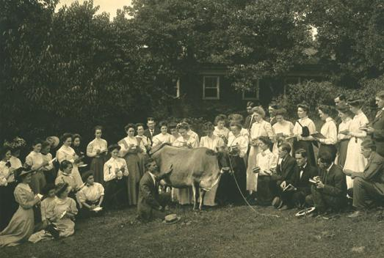
One big condition to apply was that, although men can attend college as young as 16, women were not considered mature enough to enroll until they turned 20 years old. Soon after Davis, Addis Meade applies for the mathematics department as well, but Meade is turned down due to her age. Two years later, however, in 1894, Meade is awarded a master’s degree in mathematics.

A summer agriculture class comprised mostly of women, around 1910
Faculty again began reconsidering its admissions policies for women, fearing that providing women these opportunities would lead to full coeducation. On June 11, 1894, the BOV voted against the admission of women under any circumstances.

In 1901, however, UVa begins to offer a co-ed summer school, and women are admitted to a two-year nursing diploma program at the UVa hospital.

Why were so many against the admission of women or coeducation?
Many believed that collegiate education was not suitable for women, thinking that educating women would draw them away from their domestic skills as a wife and mother. Furthermore, they were worried that the male students would lose focus with women in attendance. At UVa specifically, many feared that coeducation would be detrimental to the University’s traditions, atmosphere, standards, and reputation. Many worried that no real gentleman would turn in a woman for the Honor Code (implying that admitting women would ruin the traditions of UVa). For most, admitting women simply contradicted the values of UVa’s founding father.

What legislative actions were taken in the early 1900s?
In 1910, the Equal Suffrage League forms and Mary Munford presses the Virginia General Assembly to establish a coordinate women’s college in Charlottesville. The UVa faculty even endorsed the bill in 1911. Munford brought the coordinate college bill to the Virginia legislature five times, meeting with defeat each time. Even as women thrived at the summer school, the General Assembly held firm to the belief that UVa is truly a men’s school.

What colleges do women start to attend then?
Randolph-Macon Women’s College is founded as the first four-year all-women’s college in 1916, and (as a result of Munford and her colleagues’ efforts) the College of William and Mary co-educates in 1918.

Change in the 1920s

When did UVa officially decide to first admit women?
After the coeducation of William & Mary, in November 1919, President Alderman asks faculty to admit women to graduate and professional schools, under the condition that they’re at least 20 years of age and have two years of experience at another school. That January, the measure passes the faculty 64-4 and the BOV 7-2. The General Assembly permits it. (By this year, 2/3 of American colleges are co-ed.)

So just after the Nineteenth Amendment passes that August and women earn the right to vote, in September 1920 seventeen women enroll and register for classes at UVa, constituting less than 1% of the 1,581 students at the time

What women faculty are hired in the 1920s?
In May 1921, Adelaide Simpson becomes the first Dean of Women, and in 1922 Emilie McVea, President of Sweetbriar College, becomes the first woman appointed to the Board of Visitors.

What does female enrollment look like by mid-decade?
In 1923, Elizabeth Tompkins becomes the first woman to earn a UVa law degree. By 1925, 102 women were registered, 50% in the Curry School.

What were male student responses to coeducation?
Students did not respond favorably, and were particularly hostile in student publications. For years, a woman’s entrance into a classroom was often accompanied by male cries, whistles, and stamping feet.

What was life like for women at UVa at this time?
Indeed, in 1927, the Dean of Women complained that women “had no gathering place and were distributed among many boarding houses around the university area. They were a sad, lonely lot. Men students were so reluctant to have a woman invade their beautiful university that they would actually stand by and either ignore or laugh at any girl whose books dropped accidentally.” Indeed, women certainly had entered an institution where “gentlemanly” traditions had permeated all aspects of university life for the past century. Fraternities, clubs, and societies, whose membership had historically excluded women, dominated life on Grounds. It took years before women’s dorms existed.

So women created their own separate student government, found their own places on Grounds, and developed their own separate social lives. In 1924, a group of women formed a small local sorority named Pi Chi, but Chi Omega became the first national sorority on Grounds in 1927. In 1932, Pi Chi affiliated with the national sorority Kappa Delta.

Meanwhile, what’s Mary Munford up to?
Munford persisted in her fight for an undergraduate coordinate college for women affiliated with the University of Virginia, and in February 1928, the Virginia General Assembly passed an act to create a committee to investigate the establishment of a liberal arts college for white women in connection with UVa, called The Halsey Commission.

A Growing Presence

What did the Halsey Commission report?
In 1930, the committee outlined a plan for a women’s college affiliated with UVa, proposing several locations for the institution: possibly in Charlottesville, but more likely in Fredericksburg, Harrisonburg, or really any city at least thirty miles form Charlottesville, under the belief that the women’s college “should not be located at the University of Virginia or so near there so as to change its fundamental character.”

What action was taken?
None at first. In 1931, the Board of Visitors did endorse the Commission’s recommendation to convert a Teacher’s College into a liberal arts college for women affiliated with UVa. However, the governor vetoed the bill the following year because of a concern that funds would be diverted from the University to pay for the new college.

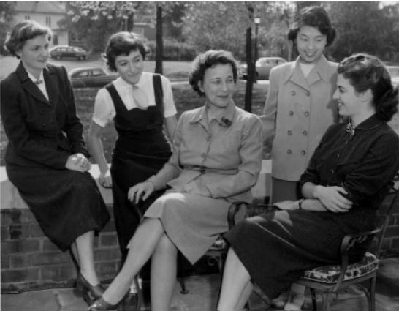
What women enrolled at UVa in the 1930s?
Several faculty wives and daughters gained acceptance in the College, especially when enrollment dropped sharply during the Great Depression and World War II.
In 1932, Margaret Glendy becomes the first women to earn her M.D. from UVa.

In 1935, Alice Jackson, an African-American female, focuses national attention on UVa’s discriminatory admissions policies when she applies to the school for a Master’s in French. The BOV denies were for “good and sufficient reasons”. The NAACP considers her case too weak, and UVa pays for her to attend Columbia University instead.

Roberta Hollingsworth Gwathmey, Dean of Women, 1934-1967, with students

Women at the University carried on, despite their tribulations. They proved to be exceptional students and gradually earned the respect of their professors and peers. By 1940, almost 200 women had enrolled at UVa.

Did they ever establish that coordinate women’s college?
After several years in limbo, the issue of a coordinate college resurfaced in the early 1940s and finally in February 1944, the General Assembly passed the Coordinate College Bill, which authorized the conversion of Mary Washington College into a women’s liberal arts college affiliated with UVa.

President Newcomb oversaw the conversion of its academic programs to ensure they were comparable to UVa. Third-year women were permitted to transfer to UVa if MWC didn’t have their major. Their degrees either said UVa or MWC of UVa.

What happens during the 1950s?
In 1951, President Darden eliminates the age restriction on women, but the women attending UVa are still not fully admitted to most undergraduate programs, typically only attending specialty schools (like doctorate Louise Stokes-Hunter in the Curry School, the first African-American woman at UVa).

In 1952, Mary Munford Hall (currently the IRC) becomes the first residence hall built specifically for the University’s female students and could accommodate up to 104 women. All female students but nurses and married women were required to live in Munford Hall. The dorm provided much-needed space for women to socialize and pursue recreational activities.

Breaking with Tradition

By 1965, there is concern that UVa is falling behind coeducational institutions, especially since its all-male counterparts (Yale, Dartmouth, Princeton) were all moving towards coeducation. The BOV charges President Shannon with studying coeducational issues: Does the present system discriminate against women? Would academics improve with women? Would social life improve with women?

From 1967-68, the study takes place for 18 months, and afterwards Shannon’s committee believes the answer is “yes” to all three. Shannon decides he is in favor of coeducation and the BOV directs him to detail a plan for implementation, as at the next meeting in February they’d be voting to lift all restrictions regarding the admission of women to the College.

How did students feel about the prospect of coeducation by this point?
Despite concerns over the effect of the change on the Honor System, on women’s colleges in Virginia, on traditions like “rolling” women’s colleges, on the University’s resources, and on alumni satisfaction, Student Council concludes that coeducation was highly desirable, and the majority of students supported it, thinking coeducation would strengthen the academic and social life of the University.

The Honor Committee concludes in a study, however, that “coeducation will hurt the Honor System, and thus should not be recommended.”

What was the plan for coeducation?
At the February meeting in 1969, the BOV did lift all admission restrictions and agreed to admit qualified student wives and daughters of faculty members during a transitional period from 1969 to 1970 (11 were admitted), and then Provost Frank Hereford began preparing a plan for gradual admission of women throughout the 1970s, capping their enrollment at 35% by 1980.

But what happened that spring?
UVa Law alumni John Lowe, representing four women, had initiated an ACLU lawsuit against the University, appealing for women’s admittance into the College. While the court did not force UVa to coeducate (it had already resolved to do so), in the Spring of 1969 the court mandated full coeducation within three years.

Why did UVa lose so badly?
UVa’s case was hurt by the fact that it was the only public university in the nation that directed female applicants to a “sister” school more than 65 miles away, and many testified that the level and quality of learning was not the same at both schools. One of those who testified was Mary Whitney, Dean of Women and Asst. Professor in the Curry School, who resigned from both jobs in order to testify on UVa’s inequality. Furthermore, by this time, UVa had become the last state school to coeducate.
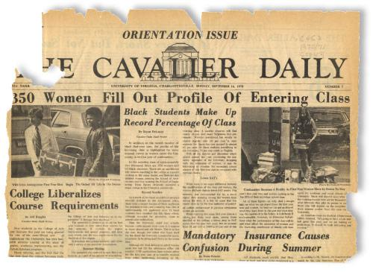
What became the coeducation plan then?

UVa quickly developed a new plan: it would admit 450 women in 1970, 550 women in 1971, and would admit students without regard to sex in 1972. The number of men would remain constant.

In Fall 1969, Virginia Scott becomes the only one of the four women involved in the suit to enroll.
In September 1970, after 150 years of exclusion, a total of 420 women (350 first-years, 39% of the class) became the first class of undergraduate women to enter the College of Arts and Sciences at UVa.

After Coeducation

What became of UVa’s relationship with Mary Washington College?
More transfers to UVa came from Mary Washington than from any other school those first few years. In 1972, the affiliation between Mary Washington College and UVa officially ended.

Did UVa start an athletics program for women?
Prior to 1970, UVa did not offer a women’s athletics program, but there were a few notable female athletes. While working on her Master’s in Education, Mary Slaughter played for the University’s tennis team. She became the first woman at UVa to participate in an athletic program and earn a varsity letter in any sport. (Slaughter Gym is named after her.) Another female athlete, Mary Brundage, competed alongside male swimmers on the varsity team in 1966 while she was a nursing student.

But with full coeducation came a women’s intercollegiate athletic program. Club sports like tennis, field hockey, and basketball started in the fall of 1971 and achieved varsity status by 1973. By 1976, the women’s athletics program had expanded to include swimming, diving, and lacrosse. The passing of Title IX in 1975 mandated that UVa provide equal opportunities and funding to men’s and women’s athletic programs, which helped to accelerate the growth of women’s athletics. Today female athletes compete in twelve varsity sports.

What were those first few years like for women?
Virginia Scott later said her time at UVa was rough, filled with men treating her poorly, questioning why she was there. Men would often stomp their feet or speak over them in class.

Over time though, women proved to be highly motivated achievers, and their determination and their abilities proved to their classmates and themselves that they belonged at the University. Disregarding the precedent of the past 150 years, they set their sights on ambitious goals and met—or surpassed—them in their four years here.

In 1972, Cynthia Goodrich moved into 28 East Lawn, becoming the first female Lawn resident, and more women received invitations the following year. Katie Couric was head resident of the Lawn in 1979. By the time the first full class graduated in 1974, these women had gained entry into organizations (Honor committee members, Lawn residents), societies (IMPs, Ravens), and leadership positions (editors of The Cavalier Daily) that had been closed to females for most of the University’s history. Leaving their indelible mark on the University, these women established that women were here to stay. By 1974, women made up 43% of the incoming class. In 1980 women comprised a majority of the incoming first-year class, and have every year since.

What are some recent events in women’s history?
The Studies in Women, Gender and Sexuality major started in 1980. The Women’s Center was founded in 1985. Teresa Sullivan became the University’s first female president in 2010, and Helen Dragas became the University’s first female Rector of the Board of Visitors in 2011. Today, women comprise 55 percent of the undergraduate student body.

Testimonials

Adapted from Sierra Bellows, Carianne King and Emma Rathbone’s Women at the University of Virginia

Constance Page Daniel, a faculty daughter and one of the first female students in a winter session, describes her experience: “If you were a woman and could breathe, you usually had four or five men following ‘round behind you...When I’d walk into a classroom, the students would all stomp. It was their signal of derision. They didn’t want coeds at the University…And if I dared to answer a question or make a comment, they’d stomp again. So I was stomped my whole way through school.”

Janet Blakeman graduated from the Law School in 1957. It was just after the Korean War, and Blakeman found herself attending the school with a number of veterans. Her class of about 150 students included only one other woman. In a field still dominated by men, they experienced their share of discrimination. “I remember a male classmate said to me, ‘You’re taking the place of a man who has to support his family.” But she says most of her classmates were pretty nice to her, and she “enjoyed being called upon, having to recite and studying in the carrels in the library.” Blakeman worked in trusts and estates law in NY for four decades. And what of the former classmate who accused her of taking another man’s job? “I saw him later. He asked what I was doing and I said, ‘I’m supporting my family!’”

Holly Smith was a 1972 graduate of the College of Arts and Sciences and one of the first female undergraduate students. “ I arrived in Charlottesville in September 1970 ready to do battle in the cause of making sure women were given equal treatment.” Smith found that male students were generally pleased to have women in their classes, but “There was a tradition that no male student would sit next to a female student in class unless all the other seats were taken. Often the men were just shy, not resentful.” Perhaps because the University had to quickly comply with a 1969 court order to admit undergraduates, Smith noticed some areas of student life where women’s needs were not provided for. As a staff member of the Cavalier Daily, she wrote about the development of health care for women and attitudes towards women athletics. Smith also tackeld the controversy about opening up Lawn rooms to women. In an interview, Smith asked the director of housing why women couldn’t live on the Lawn. “Bathrooms,” he told her.

Sandra Lewis was an African-American 1972 graduate of the College. She joined her husband at UVa as a student in 1970, and said she did not encounter any resistance from anyone that she can recall. Her perspective might have been different if she had been single though, she says, because Lewis lived in married student housing and socialized with other married couples. “I was at UVa when the Vietnam War was going on. We had very traditional, necktie-wearing students and then we had the 60s radicals. It was a campus that was in an uproar. She says that the only negative experience was that “even though there were African Americans attending at the time, I don’t think there was a lot of integration of the group into the campus life.”

Assorted Contemporary Stories

Georgia O’Keefe at UVa

Gore, Mary Jane. Georgia at Virginia: Charlottesville Helped Shape the Artist’s Vision. UVa Alumni News: 1999.

Who and When: An artist whose family moved to Charlottesville in 1909. She studied at the Art Students League in New York City and won the top prize for a still life of a dead rabbit stretched diagonally beside a copper pot. She taught at the University in the summers of 1913-1916.
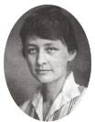
Connection to UVa: In 1912, O’Keefe learned that the University was opening its doors to women for the first time, for the summer session only. She studied there for a summer and returned to teach. She is listed in the University Bulletin as a full time instructor of Drawing 2, 3, and 4.

The light illuminating the soft curves of the Rotunda’s dome and its solid base caught her imagination. Through her life, she was moved to create dramatic curves in shades of black as well as color. Her initial breakthrough as an undeniably original artist occurred in 1916, the same year she left Charlottesville. She brought forth quizzical-but-beautiful forms, odd shapes and flowing lines that appealed to her innately. With these charcoal abstractions, she created a stir.

While teaching, O’Keefe fell in love with Arthur Macmahon, a professor of government at the summer school. Though their love affair did not last, her passion led her to one of her more famous charcoal abstraction series. O’Keefe returned to her schooling in New York but was called back to Charlottesville once more with the news that her mother had died. O’Keefe slipped into a lethargy that lasted as she taught one more summer before moving to Texas. She died in New Mexico in 1986 at age 98.

William Faulkner at UVa

Ringle, Ken. Faulkner: Between the Lines: The Author was Hard to Read, Even in Person. The Washington Post: 1997.

Who and When: Faulkner (1897-1962) was an American writer and Nobel Prize laureate from Oxford, Mississippi. Faulkner worked in a variety of written media, including novels, short stories, a play, poetry, essays and screenplays. He is primarily known and acclaimed for literature based on the American South.

Connection to UVa: Faulkner was the University’s first writer in residence in 1957 and 1958 . His agreement with the University specified that he was required to give no more than an occasional speech and no classroom lectures at all, but was to hold office hours. A student at the time says that the novelist rarely said much. “We would sit there gaping, wracking our under-booked brains for some question that wouldn’t make us look stupid. ‘Mr. Faulkner, in your short story The Bear, do you consider the bear a positive nature symbol or a negative nature symbol of both like the white whale in Moby Dick?’ … ‘Oh, he’d eventually say in his thin, reedy voice, after puffing on his pipe long enough to raise the suspence: ‘That’s just a story about a bear.’” Faulkner himself, who lacked even a high school diploma and was famously disdainful of academics, remained polite but distant, countering scholar’s questions with mischievously opaque replies.

Alderman Library’s Special Collections recently obtained 39 letters Faulkner wrote to his family while working for Warner Bros. as a screenwriter during World War II

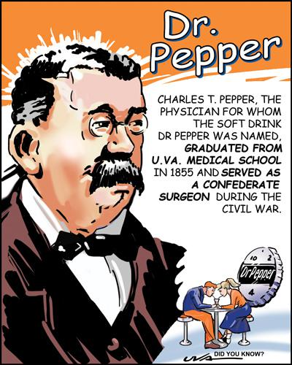
Dr. Pepper

The physician for whom the soft drink “Dr. Pepper” was named. Pepper earned his medical degree in 1855 from the UVa Medical School, then served as a surgeon for the Confederacy during the Civil War. After the war, Pepper moved to Rural Retreat, Va, where he practiced medicine and opened a drugstore. Pepper employed a young pharmacist named Wade Morrison, who would go on to create the “Dr. Pepper” soft drink that was served at his soda fountain. The UVa connection has been confirmed by James Ball, the former VP of corporate communications for Dr. Pepper/Seven-Up.

According to some legends, Morrison was in love with Pepper’s daughter and named the drink for the doctor in hopes of winning his approval.
Another story maintains that it was Morrison’s way of thanking Pepper for giving him his first job. Rural Retreat locals claim that Morrison merely mass-produced a fizzy beverage made of mountain herbs and roots originally concocted by Pepper.

Others theorize that the name Dr. Pepper was chosen to bolster early marketing claims that the drink was an energizing brain tonic. Whatever the true story is, Charles Pepper never profited from the arrangement. According to a New York Times article, “Dr. Pepper went on to fame, but no fortune, as the brew’s namesake.”

Beta and Seal

In the first half of the 20th century, a pair of dogs captured the hearts and imaginations of the entire University. The first was Beta, a black-and-white mutt built like a bull terrier, who roamed freely around Grounds during the 1920s and ’30s. Hailed as the nation’s “No. 1 College Dog,” he was pictured in a 1937 issue of Look magazine and was the topic of a national radio show sponsored by Pontiac. Beta’s appetite for beer and hamburgers was legendary, but his interests weren’t limited to the creature comforts—he also avidly pursued his academic interests. His regular attendance at classes earned him another nickname: Aristotle. In a 1980 letter to the Washington Post, a contemporary recalls “unearthing a photo of that gentlemanly dog, ensconced at a booth in a local eatery, white napkin tied round his neck.”
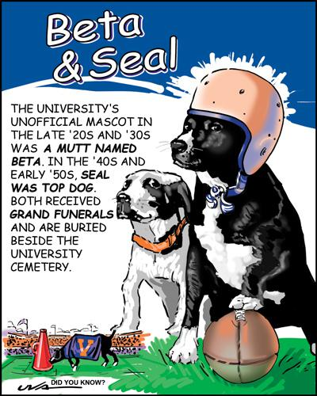
Seal, a cross-eyed mongrel with a shiny black coat who was the University’s mascot from 1947 to 1953, enjoyed similar dining privileges around town. Restaurant signs of the day read, “No Dogs Allowed (Except Seal).” Seal’s crowning moment came at Philadelphia’s Franklin Field during halftime of the 1949 Pennsylvania-Virginia football game. As described by the Cavalier Daily, Seal slowly “walked from midfield to the Quaker side. Indifferently he inspected their cheerleading appurtenances. Eighty thousand people watched with bated breath. Coolly, insolently, Seal lifted a leg—the rest is history.”
The beloved dogs are buried side by side, just outside of the University Cemetery. An estimated 1,000 mourners attended Beta’s 1939 funeral, while more than 1,500 attended Seal’s burial in 1953.

Carr’s Hill

Until 1904, the University’s system of governance did not include a president. Thomas Jefferson’s minimal system called for just two managers: the rector, or head of the Board of Visitors, and the chair of the University’s faculty. But the chaos surrounding the 1895 Rotunda fire and subsequent reconstruction served as a wake-up call that the University needed a better managerial system to handle such a large project.

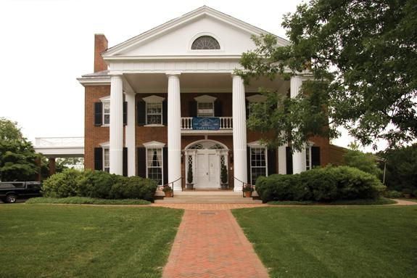
Stanford White, the renowned architect of the time and a partner in the firm of McKim, Mead & White, designed Carr’s Hill but was murdered before completing the plans. Another architect with the firm, William Kendall, finished the design. U.Va.’s first president, Edwin A. Alderman, wanted the dwelling to be both symbolic and functional, desiring a plan similar to a house he admired in New Orleans. “To serve as the social locus of the University’s presidency, the Aldermans were not seeking a Gilded Age plutocrat’s house built for pleasure,” Margaret Gutman Klosko (Grad ’91) writes,“Instead, they sought a hard-working house.”

To call Carr’s Hill a working house might be an understatement. Though the residence is spacious—10,450 square feet with six bedrooms and eight bathrooms—the social engagements held there have multiplied as the University has grown. Today, about 14,000 guests are entertained there annually. One longstanding tradition has been to invite the first-year class to Carr’s Hill the day after students arrive.

Innovations at the Engineering School

University of Virginia Magazine. Research and Discovery: The Mother of Invention. Winter 2011.

The First Crash Tests at Virginia: If you drive a car, you’re probably safer because of professor Walter D. Pilkey. He founded the Automobile Safety Laboratory at UVa, now the Center for Applied Biomechanics, in 1989. Not only did Pilkey set up a sled with a simulated occupant compartment to study the effects of rapid deceleration on crash-test dummies, but he also created computer programs that allowed car manufacturers at Ford to design safer cars.

Three Times Stronger than Steel: By mixing metals and non-metals following a specific recipe, heating them up to more than 1,000 degrees and then cooling them, UVa professors created an alloy that is not only 300% stronger than steel, but also nonmagnetic and more resistant to corrosion.

A Window into the Body: Professor William Walker’s roommate was a medical student who complained that there wasn’t an easy way to see inside the infants that he was treating. It was hard to find their small arteries. So in the early 1990s, Walker created a hand-held ultrasound device.

The Eyes Speak: In the early 1980s, professor Thomas Hutchinson visited children with disabilities in the UVa hospital and saw that other than wheelchairs, there was little existing technology that improved their lives. Later, while watching a nature documentary, he realized that he could tell where an elephant’s eye was looking because of the way it reflected light. This led him to design the Eye-gaze Response Interface Computer Aid (ERICA), which tracked eye movement with a camera while a person looked at a screen and a computer analyzed the movement so that the user could speak or write. ERICA brought the gift of communication to people unable to speak because of conditions such as cerebral palsy, stroke and ALS.

Presidential Chronology

You should be able to name all eight of UVa’s Presidents.

1825 No President

1904 Edwin Alderman

1931 John Newcomb

1947 Colgate Darden

1959 Edgar Shannon

1974 Frank Hereford

1985 Robert O’Neill

1990 John Casteen

2010 Teresa Sullivan

Additional Citations:

Viccellio, Robert. Did you Know? A Collection of University esoterica. UVa Magazine, Winter 2009. Assorted Alumni News articles from the 20th century
Singleton, Maura. The Vision for the Village. UVa Magazine, Fall 2009.

